Bookdown test

subtitle goes here

Jack Dougherty

and contributors

2020-01-06

# Preface

This is a test book

This work is licensed under a Creative Commons Attribution-NonCommercial-ShareAlike 4.0 International License.

## Authors and Contributors

Info about each author

Info about each author

Info about each author

Info about each author

Info about each author

Info about each author

Info about each author

and contributor

## Copyright with Open License

All text and code for this book is available on [GitHub](https://github.com/jackdougherty/bookdown-test). This work is licensed under a Creative Commons Attribution-NonCommercial-ShareAlike 4.0 International License.

# Video Tests

Problem: Video stream content from CT Digital Archives and Trinity Kaltura automatically runs in autoplay mode in web browsers, and I have not yet found a consistent way to block this from happening.

**BEFORE TESTING**: TEST in both Firefox and Chrome for auto-play issue. Make sure that your browser settings do NOT block autoplay content by default, since we cannot ensure that users will have same browser settings as developers.

#### Best solution so far: Upload relevant clip to YouTube to display as iframe in web edition, with static image in PDF/Word editions, with caption link and footnote to full video, uploaded for historical preservation to CTDA or Kaltura

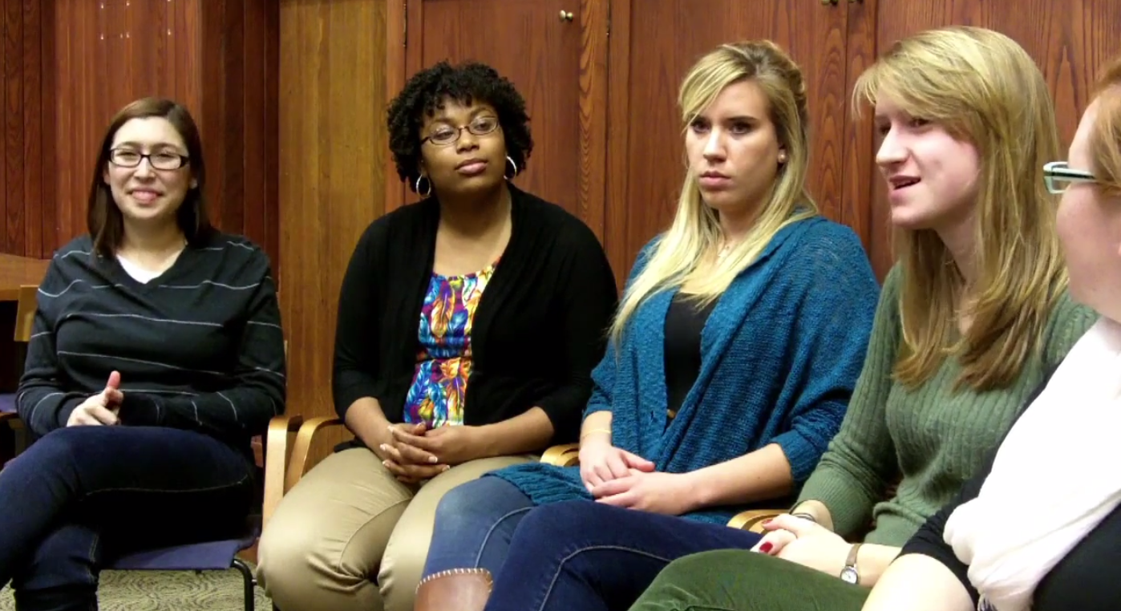

Image 1: Here’s a sample YouTube caption, with option to add Markdown links and footnote to full video at CTDA.

#### Works: Kaltura HTML5 embed avoids autoplay, but is it still supported?

…as shown below in 2.[1]. See additional oral histories with participants in the Sheff v O’Neill school desegregation lawsuit.[2]

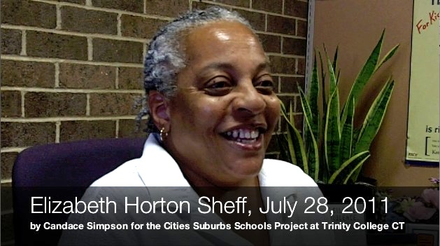

Image 2: View the [oral history video interview and transcript](http://digitalrepository.trincoll.edu/cssp_ohistory/16) with Elizabeth Horton Sheff in 2011.

#### Works but not properly formatted: Kaltura default embed code avoids autoplay

…as shown below in 3.This is actually Anne Goldstein.



Image 3: This is actually Anne Goldstein sample video.

#### Issue Background

Here is an oral history video as displayed on the CTDA site, which does NOT autoplay:

<https://collections.ctdigitalarchive.org/islandora/object/120002:172>

Here is the CTDA MP4 video stream for that object, which runs AUTOPLAY in Chrome and FFox for Mac (and perhaps other browsers). CTDA says there is no setting to turn off autoplay from datastreams

<https://collections.ctdigitalarchive.org/islandora/object/120002:172/datastream/MP4>

The stream above also works with this “view” ending, but also runs autoplay:

<https://collections.ctdigitalarchive.org/islandora/object/120002:172/datastream/MP4/view>

#### Failed: CTDA iframe with autoplay=false

Here is Bookdown code-chunk that displays CTDA video in web edition, static image in PDF edition, BUT CANNOT TURN OFF AUTOPLAY using the iframe method, even if I add “?autoplay=0” or “?autoplay=false” to the end of the src string, as suggested in Stackoverflow further below.

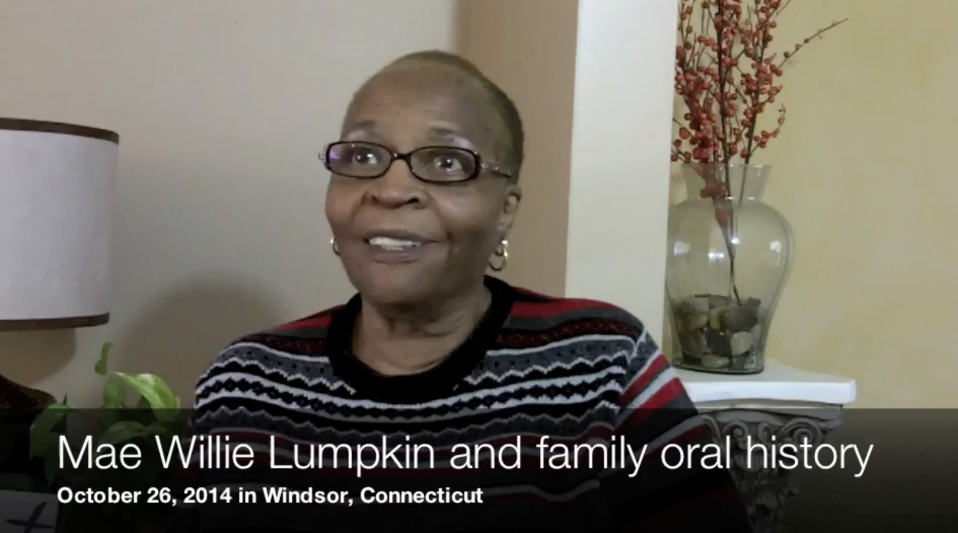

Image 4: Here’s a sample CTDA video caption, with option to add Markdown link and footnote.

Also tried but did not succeed in adding a “no autoplay” command to the iframe through jQuery in the custom-script.html

#### Not Bookdown-friendly: HTML5 video tag solution

Here’s a solution using the [HTML5 video tag](https://www.w3schools.com/tags/tag_video.asp), which inserts user “controls” but omits “autoplay”.

The HMTL5 video tag solution stops autoplay, but it is NOT ideal for Bookdown-generated books because:

* Bookdown/knitr does not *appear* to support the HMTL 5 video tag in the same way as it supports knitr::include_url. I could submit a request to Bookdown to support HTML5 video tag, but it’s not likely to happen soon….
* This means that I cannot use Bookdown built-in support for figures using the HMTL5 video tag, such as:
  + the if-else statement in the R code-chunk that places the interactive iframe in HTML and the static floating image in the PDF, but the same caption for both
  + figure auto-numbering, such as Figure 1.2, 1.3, etc.

#### Failed: iframe solution with short video clip, stored locally, with custom script - but it autoplays

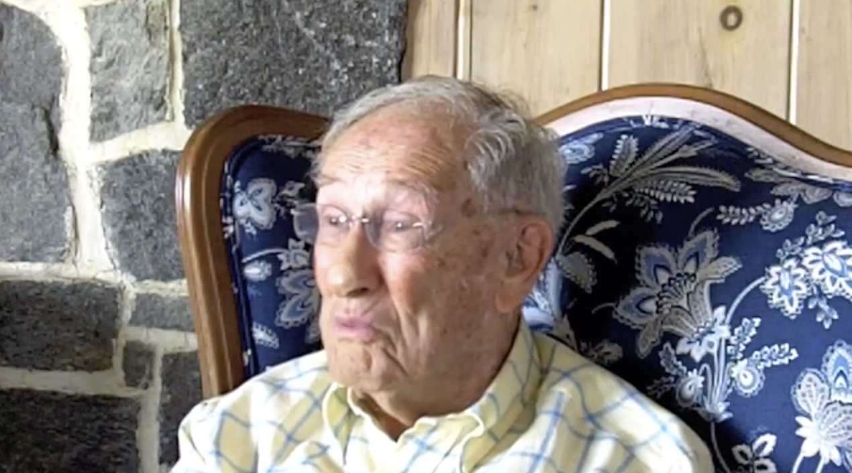

Image 5: Here’s a sample local video clip caption, with option to add Markdown link and footnote.

An alternative method is to store the video locally and display with HTML5 video tags, with a custom-script to stop auto-play. But Bookdown does not recognize HMTL5, so no figure auto-numbering and captions will be displayed, and therefore not ideal, as described above.

#### More resources

See Stackoverflow discussions about HTML iframe, HTML5 video, and autoplay:

<https://stackoverflow.com/questions/49256942/how-to-disable-autoplay-video-in-iframe> and <https://stackoverflow.com/questions/31956221/how-to-disable-auto-play-for-local-video-in-iframe>

See Google Chrome Developer autoplay policy change in April 2018:

<https://developers.google.com/web/updates/2017/09/autoplay-policy-changes>

See Firefox Developer note for Video HTML5 autoplay:

<https://developer.mozilla.org/en-US/docs/Web/HTML/Element/video>

# Notes chapter test

Testing dynamic reference with footnote

In addition its financial assets, Clark also praised Hartford’s abundant cultural riches. The nation’s best-known authors, Samuel Clemens (more commonly known as Mark Twain) and Harriet Beecher Stowe (whose best-seller, *Uncle Tom’s Cabin*, influenced the Civil War), both took up residence in the city, alongside many of their literary companions, editors, and publishers. In addition to serving as the state capital, Hartford prized its extensive libraries, museum, and hospital. “The Hartford school buildings are said to the finest in the State,” Clark added, and called special attention to his alma mater, Hartford Public High School, the second oldest in the nation, which also enjoyed “a reputation with all the leading colleges as one of the best of all the preparatory schools,” as shown in Figure 6.[3] In fact, the education that young people received in the city’s public school system far surpassed what was available in the outlying rural towns, known today as the suburbs.

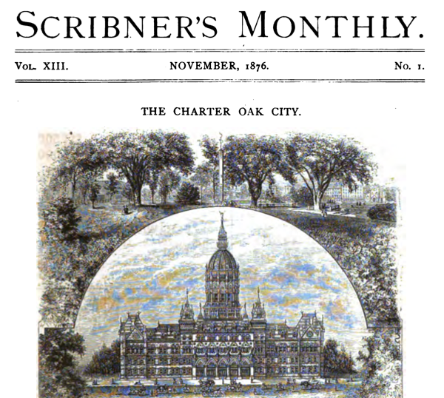

Image 6: Scroll [the full-screen document](https://ontheline.github.io/otl-google-books-api/scribners-monthly-1876.html) from *Scribner’s Monthly* in 1876, which declared Hartford as “the richest city in the United States,” relative to its population. Digitized by Google Books.

Lorem ipsum dolor sit amet, consectetur adipisicing elit, sed do eiusmod tempor incididunt ut labore et dolore magna aliqua. Ut enim ad minim veniam, quis nostrud exercitation ullamco laboris nisi ut aliquip ex ea commodo consequat. Duis aute irure dolor in reprehenderit in voluptate velit esse cillum dolore eu fugiat nulla pariatur. Excepteur sint occaecat cupidatat non proident, sunt in culpa qui officia deserunt mollit anim id est laborum.[4]

Lorem ipsum dolor sit amet, consectetur adipisicing elit, sed do eiusmod tempor incididunt ut labore et dolore magna aliqua. Ut enim ad minim veniam, quis nostrud exercitation ullamco laboris nisi ut aliquip ex ea commodo consequat. Duis aute irure dolor in reprehenderit in voluptate velit esse cillum dolore eu fugiat nulla pariatur. Excepteur sint occaecat cupidatat non proident, sunt in culpa qui officia deserunt mollit anim id est laborum.[5]

Lorem ipsum dolor sit amet, consectetur adipisicing elit, sed do eiusmod tempor incididunt ut labore et dolore magna aliqua. Ut enim ad minim veniam, quis nostrud exercitation ullamco laboris nisi ut aliquip ex ea commodo consequat. Duis aute irure dolor in reprehenderit in voluptate velit esse cillum dolore eu fugiat nulla pariatur. Excepteur sint occaecat cupidatat non proident, sunt in culpa qui officia deserunt mollit anim id est laborum.[6]

Lorem ipsum dolor sit amet, consectetur adipisicing elit, sed do eiusmod tempor incididunt ut labore et dolore magna aliqua. Ut enim ad minim veniam, quis nostrud exercitation ullamco laboris nisi ut aliquip ex ea commodo consequat. Duis aute irure dolor in reprehenderit in voluptate velit esse cillum dolore eu fugiat nulla pariatur. Excepteur sint occaecat cupidatat non proident, sunt in culpa qui officia deserunt mollit anim id est laborum. Duis aute irure dolor in reprehenderit in voluptate velit esse cillum dolore eu fugiat nulla pariatur. Excepteur sint occaecat cupidatat non proident, sunt in culpa qui officia deserunt mollit anim id est laborum.[7]

Lorem ipsum dolor sit amet, consectetur adipisicing elit, sed do eiusmod tempor incididunt ut labore et dolore magna aliqua. Ut enim ad minim veniam, quis nostrud exercitation ullamco laboris nisi ut aliquip ex ea commodo consequat. Duis aute irure dolor in reprehenderit in voluptate velit esse cillum dolore eu fugiat nulla pariatur. Excepteur sint occaecat cupidatat non proident, sunt in culpa qui officia deserunt mollit anim id est laborum.[8]

Lorem ipsum dolor sit amet, consectetur adipisicing elit, sed do eiusmod tempor incididunt ut labore et dolore magna aliqua. Ut enim ad minim veniam, quis nostrud exercitation ullamco laboris nisi ut aliquip ex ea commodo consequat. Duis aute irure dolor in reprehenderit in voluptate velit esse cillum dolore eu fugiat nulla pariatur. Excepteur sint occaecat cupidatat non proident, sunt in culpa qui officia deserunt mollit anim id est laborum..[9]

Lorem ipsum dolor sit amet, consectetur adipisicing elit, sed do eiusmod tempor incididunt ut labore et dolore magna aliqua. Ut enim ad minim veniam, quis nostrud exercitation ullamco laboris nisi ut aliquip ex ea commodo consequat. Duis aute irure dolor in reprehenderit in voluptate velit esse cillum dolore eu fugiat nulla pariatur. Excepteur sint occaecat cupidatat non proident, sunt in culpa qui officia deserunt mollit anim id est laborum.Lorem ipsum dolor sit amet, consectetur adipisicing elit, sed do eiusmod tempor incididunt ut labore et dolore magna aliqua. Ut enim ad minim veniam, quis nostrud exercitation ullamco laboris nisi ut aliquip ex ea commodo consequat.[10]

#### Fourth-level header non-numbered

Lorem ipsum dolor sit amet, consectetur adipisicing elit, sed do eiusmod tempor incididunt ut labore et dolore magna aliqua. Ut enim ad minim veniam, quis nostrud exercitation ullamco laboris nisi ut aliquip ex ea commodo consequat. Duis aute irure dolor in reprehenderit in voluptate velit esse cillum dolore eu fugiat nulla pariatur. Excepteur sint occaecat cupidatat non proident, sunt in culpa qui officia deserunt mollit anim id est laborum.[11]

##### Fifth-level header non-numbered

Lorem ipsum dolor sit amet, consectetur adipisicing elit, sed do eiusmod tempor incididunt ut labore et dolore magna aliqua. Ut enim ad minim veniam, quis nostrud exercitation ullamco laboris nisi ut aliquip ex ea commodo consequat. Duis aute irure dolor in reprehenderit in voluptate velit esse cillum dolore eu fugiat nulla pariatur. Excepteur sint occaecat cupidatat non proident, sunt in culpa qui officia deserunt mollit anim id est laborum.[12]

Lorem ipsum dolor sit amet, consectetur adipisicing elit, sed do eiusmod tempor incididunt ut labore et dolore magna aliqua. Ut enim ad minim veniam, quis nostrud exercitation ullamco laboris nisi ut aliquip ex ea commodo consequat. Duis aute irure dolor in reprehenderit in voluptate velit esse cillum dolore eu fugiat nulla pariatur. Excepteur sint occaecat cupidatat non proident, sunt in culpa qui officia deserunt mollit anim id est laborum.[13]

Testing hashtag cross-reference to the media chapter

Testing hashtag cross-reference to the subchapter section

Testing html cross-reference to the [bibliography chapter](bibliography.html)

## Notes subchapter test

Minor revision More text here More text here More text here More text here More text here More text here More text here More text here More text here More text here More text here More text here More text here More text here More text here More text here More text here More text here More text here More text here More text here More text here More text here More text here More text here More text here More text here More text here More text here.[14]

Lorem ipsum dolor sit amet, consectetur adipisicing elit, sed do eiusmod tempor incididunt ut labore et dolore magna aliqua. Ut enim ad minim veniam, quis nostrud exercitation ullamco laboris nisi ut aliquip ex ea commodo consequat. Duis aute irure dolor in reprehenderit in voluptate velit esse cillum dolore eu fugiat nulla pariatur. Excepteur sint occaecat cupidatat non proident, sunt in culpa qui officia deserunt mollit anim id est laborum.[15]

Lorem ipsum dolor sit amet, consectetur adipisicing elit, sed do eiusmod tempor incididunt ut labore et dolore magna aliqua. Ut enim ad minim veniam, quis nostrud exercitation ullamco laboris nisi ut aliquip ex ea commodo consequat. Duis aute irure dolor in reprehenderit in voluptate velit esse cillum dolore eu fugiat nulla pariatur. Excepteur sint occaecat cupidatat non proident, sunt in culpa qui officia deserunt mollit anim id est laborum.[16]

Lorem ipsum dolor sit amet, consectetur adipisicing elit, sed do eiusmod tempor incididunt ut labore et dolore magna aliqua. Ut enim ad minim veniam, quis nostrud exercitation ullamco laboris nisi ut aliquip ex ea commodo consequat. Duis aute irure dolor in reprehenderit in voluptate velit esse cillum dolore eu fugiat nulla pariatur. Excepteur sint occaecat cupidatat non proident, sunt in culpa qui officia deserunt mollit anim id est laborum.[17]

# PDF image testing

Note that auto_pdf is true in global options

Lorem ipsum dolor sit amet, consectetur adipisicing elit, sed do eiusmod tempor incididunt ut labore et dolore magna aliqua. Ut enim ad minim veniam, quis nostrud exercitation ullamco laboris nisi ut aliquip ex ea commodo consequat. Duis aute irure dolor in reprehenderit in voluptate velit esse cillum dolore eu fugiat nulla pariatur. Excepteur sint occaecat cupidatat non proident, sunt in culpa qui officia deserunt mollit anim id est laborum.[18]

##### Static image in all editions, no interactive version

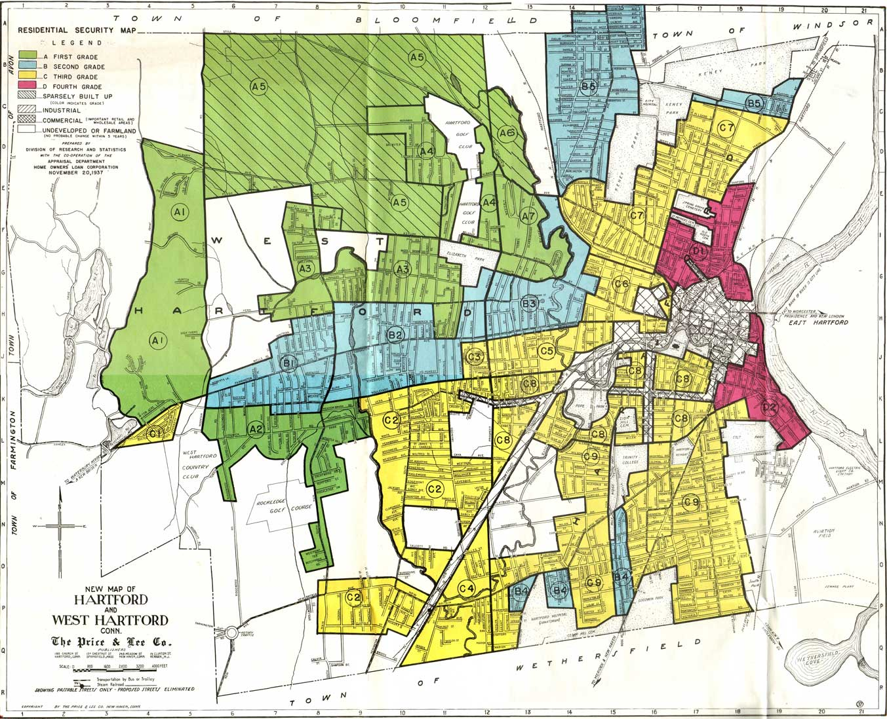

Image 7: Caption for sample static image, with Markdown formatting, links, citation.

Lorem ipsum dolor sit amet, consectetur adipisicing elit, sed do eiusmod tempor incididunt ut labore et dolore magna aliqua. Ut enim ad minim veniam, quis nostrud exercitation ullamco laboris nisi ut aliquip ex ea commodo consequat. Duis aute irure dolor in reprehenderit in voluptate velit esse cillum dolore eu fugiat nulla pariatur. Excepteur sint occaecat cupidatat non proident, sunt in culpa qui officia deserunt mollit anim id est laborum.[19]

##### Interactive iframe in web edition (with adjusted height), static image in PDF edition, WITH auto_pdf

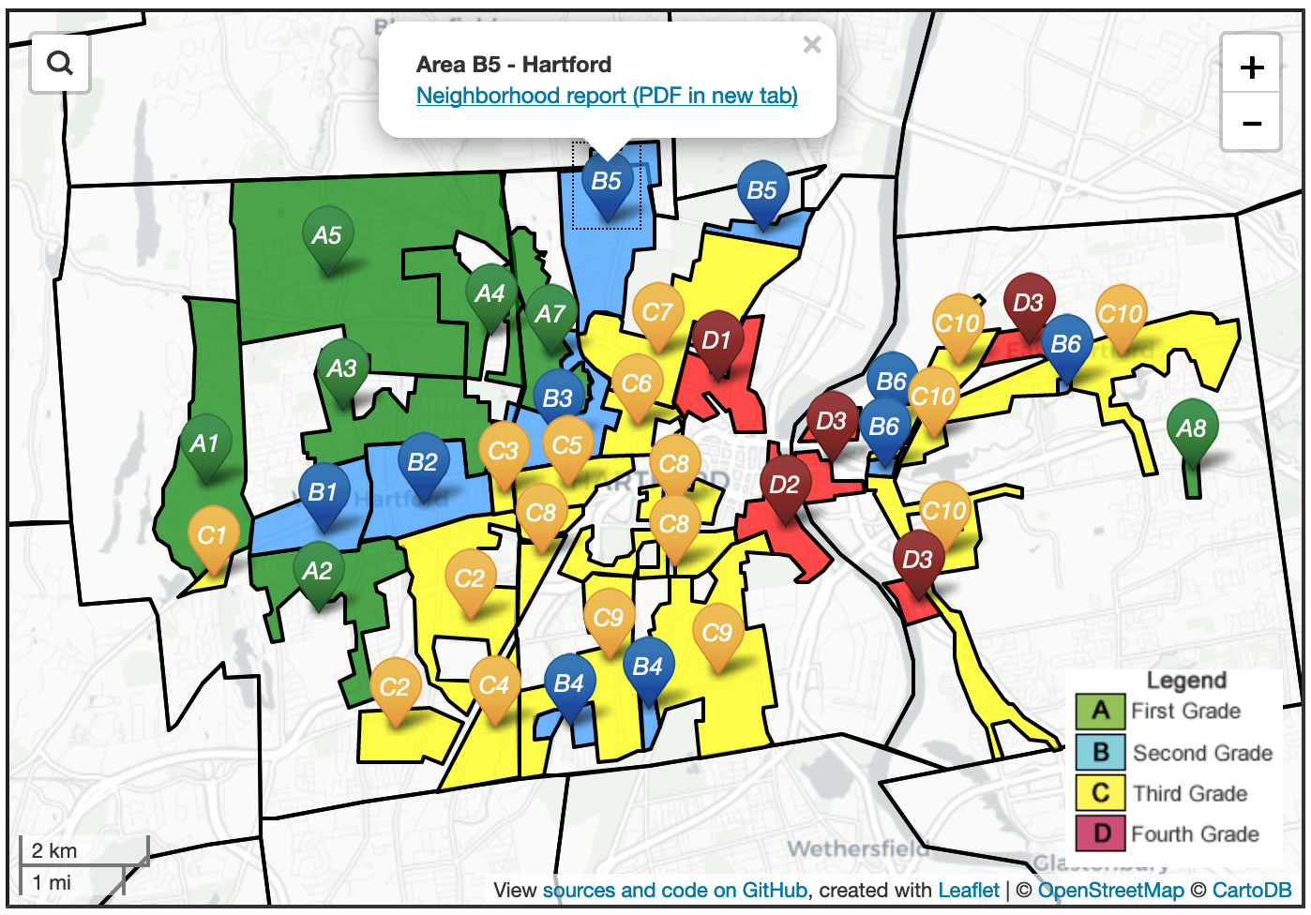

Image 8: Caption for all versions here, with link to [full-screen interactive map with its own caption](https://ontheline.github.io/otl-redlining/index-caption.html), and link to sources and the code View [map historical sources, known issues, and the code](https://github.com/ontheline/otl-redlining/), developed by Ilya Ilyankou and Jack Dougherty, with footnote (if I can get it to work)

# Table test

## Authors and Contributors

|  |  |
| --- | --- |
|  | Authors and Contributors |
| Security Grade | Second |
| Location | Hartford |
| Trend Next Decade | Stable |

 Jack Dougherty, the lead author of *On The Line*, is Professor of Educational Studies and Director of the Center for Hartford Engagement and Research (CHER) at Trinity College. He collaborates with students, colleagues, and community partners to explore cities, suburbs, and schools in metropolitan Hartford, Connecticut, using data visualization, digital history, and web writing tools. Contact him on his [faculty profile page](http://internet2.trincoll.edu/facprofiles/Default.aspx?fid=1004266), or follow him [on Twitter](http://twitter.com/doughertyjack) or on his blog <http://jackdougherty.org>.

#### Co-Authors



Jasmin Agosto (Trinity College Class of 2010 with bachelor’s degree in American Studies and Educational Studies) co-authored [Mobilizing Against Racial Steering and Redlining](mobilizing.html), and also researched 18th-19th century school documents, and decades of school residency cases. Photo by Seth Markle.



Ilya Ilyankou (Trinity College Class of 2018 with bachelor’s degree in Computer Science and Studio Arts) developed several interactive maps in this book. His open-source code and map links are available at our GitHub public repository: <http://github.com/OnTheLine/>.



Vianna Iorio (Trinity College Class of 2019 with double major in Educational Studies and English) co-authored [Restricting with Property Covenants](restricting.html), [Mobilizing Against Racial Steering and Redlining](mobilizing.html), [Jumping the School District Line](jumping.html), and more chapters to come.



Katie Campbell Levasseur (Trinity College Class of 2011 with bachelor’s degree in Educational Studies and Mathematics) conducted restrictive covenant property records research and co-authored [How We Found Restrictive Covenants](covenants.html).



JiYun (Lisa) Lee (Trinity College Class of 2017 with bachelor’s degree in Educational Studies and Psychology) co-authored [Jumping the School District Line](jumping.html).



Shaun McGann (Trinity Colege Class of 2014 with bachelor’s degree in Political Science and Urban Studies) co-authored [Federal Lending and Redlining](lending.html).



Candace Simpson (Trinity College Class of 2012 with bachelor’s degree in Educational Studies) co-authored [Who Owns Oral History? A Creative Commons Solution](teaching-researching.html#who-owns-oral-history-a-creative-commons-solution) and conducted oral history interviews on restrictive property covenants and Sheff v. O’Neill.



Tracey M. Wilson (Trinity College Class of 1976) co-authored [Restricting with Property Covenants](separating.html#restricting-with-property-covenants). See related chapters in her 2018 open-access book, *Life in West Hartford*,(<http://lifeinwesthartford.org>).

# Bibliography

Berends, Mark, Marisa Cannata, and Ellen Goldring, eds. *School Choice and School Improvement*. Cambridge Mass.: Harvard Education Press, 2011. <http://www.hepg.org/hep-home/books/school-choice-and-school-improvement>.

Cities Suburbs and Schools Project Archives, Trinity College Digital Repository. Accessed July 15, 2019. <https://digitalrepository.trincoll.edu/cssp_papers/>.

Clark, Charles H. “The Charter Oak City.” *Scribner’s Monthly* 13, no. 1 (November 1876): 1–21. <https://books.google.com/books?id=2q_PAAAAMAAJ&pg=PA1#v=onepage&q&f=false>.

Dougherty, Jack. “Bridging the Gap Between Urban, Suburban, and Educational History.” In *Rethinking the History of American Education*, edited by William Reese and John Rury, 245–59. New York: Palgrave MacMillan Press, 2007. <http://digitalrepository.trincoll.edu/cssp_papers/5/>.

———. “Conflicting Questions: Why Historians and Policymakers Miscommunicate on Urban Education.” In *Clio at the Table: Using History to Inform and Improve Education Policy*, edited by Kenneth Wong and Robert Rothman, 251–62. New York: Peter Lang, 2009. <http://digitalrepository.trincoll.edu/cssp_papers/4/>.

———. “Review of ’Connecticut’s Public Schools: A History, 1650-2000’ by Christopher Collier.” *Connecticut History* 50, no. 1 (2011): 120–22. <http://digitalrepository.trincoll.edu/cssp_papers/41>.

Dougherty, Jack, Jeffrey Harrelson, Laura Maloney, Drew Murphy, Russell Smith, Michael Snow, and Diane Zannoni. “School Choice in Suburbia: Test Scores, Race, and Housing Markets.” *American Journal of Education* 115, no. 4 (August 2009): 523–48. <http://digitalrepository.trincoll.edu/cssp_papers/1>.

Dougherty, Jack, Jesse Wanzer, and Christina Ramsay. “Sheff V. O’Neill: Weak Desegregation Remedies and Strong Disincentives in Connecticut, 1996-2008.” In *From the Courtroom to the Classroom: The Shifting Landscape of School Desegregation*, edited by Claire Smrekar and Ellen Goldring, 103–27. Cambridge, MA: Harvard Education Press, 2009. <http://digitalrepository.trincoll.edu/cssp_papers/3/>.

On The Line Digital Archives, Connecticut Digital Archives, n.d. <https://collections.ctdigitalarchive.org/islandora/object/120002:otl>.

Pennington, Lis, Emily Steele, and Jack Dougherty. “A Political History of School Finance Reform in Metropolitan Hartford, Connecticut, 1945-2005.” American Educational Research Association conference paper, April 2007. <http://digitalrepository.trincoll.edu/cssp_papers/29/>.

Sheff, Elizabeth Horton. “Oral History Interview on Sheff Vs. O’Neill.” Cities, Suburbs, Schools Project, Trinity College Digital Repository, July 28, 2011. <http://digitalrepository.trincoll.edu/cssp_ohistory/16>.

Tegeler, Philip, ed. *Finding Common Ground: Coordinating Housing and Education Policy to Promote Integration*. Washington, DC: Poverty & Race Research Action Council, 2011. <http://www.prrac.org/pdf/HousingEducationReport-October2011.pdf>.

Wells, Amy Stuart, Bianca J. Baldridge, J. Duran, C. Grzesikowski, R. Lofton, A. Roda, M. Warner, and T. White. “Boundary Crossing for Diversity, Equity, and Achievement: Interdistrict School Desegregation and Educational Opportunity.” Cambridge MA: Charles Hamilton Houston Institute for Race and Justice, November 2009. <http://charleshamiltonhouston.org/assets/documents/publications/Wells_BoundaryCrossing.pdf>.

Whitten, Robert Harvey. *West Hartford Zoning: Report to the Zoning Commission on the Zoning of West Hartford*. West Hartford, Conn: Zoning Commission, 1924. <http://magic.lib.uconn.edu/magic_2/raster/37840/hdimg_37840_155_1924_unkn_CSL_1_p.pdf>.

1. Elizabeth Horton Sheff, “Oral History Interview on Sheff Vs. O’Neill” (Cities, Suburbs, Schools Project, Trinity College Digital Repository, July 28, 2011), <http://digitalrepository.trincoll.edu/cssp_ohistory/16>
2. Trinity College Digital Repository Cities Suburbs and Schools Project Archives, accessed July 15, 2019, <https://digitalrepository.trincoll.edu/cssp_papers/>; On The Line Digital Archives, Connecticut Digital Archives, n.d., <https://collections.ctdigitalarchive.org/islandora/object/120002:otl>.
3. Charles H. Clark, “The Charter Oak City,” *Scribner’s Monthly* 13, no. 1 (November 1876): 1–21, <https://books.google.com/books?id=2q_PAAAAMAAJ&pg=PA1#v=onepage&q&f=false>
4. Philip Tegeler, ed., *Finding Common Ground: Coordinating Housing and Education Policy to Promote Integration* (Washington, DC: Poverty & Race Research Action Council, 2011), <http://www.prrac.org/pdf/HousingEducationReport-October2011.pdf>.
5. Robert Harvey Whitten, *West Hartford Zoning: Report to the Zoning Commission on the Zoning of West Hartford* (West Hartford, Conn: Zoning Commission, 1924), <http://magic.lib.uconn.edu/magic_2/raster/37840/hdimg_37840_155_1924_unkn_CSL_1_p.pdf>.
6. Lis Pennington, Emily Steele, and Jack Dougherty, “A Political History of School Finance Reform in Metropolitan Hartford, Connecticut, 1945-2005” (American Educational Research Association conference paper, April 2007), <http://digitalrepository.trincoll.edu/cssp_papers/29/>.
7. Jack Dougherty, “Review of ’Connecticut’s Public Schools: A History, 1650-2000’ by Christopher Collier,” *Connecticut History* 50, no. 1 (2011): 120–22, <http://digitalrepository.trincoll.edu/cssp_papers/41>.
8. Jack Dougherty, “Conflicting Questions: Why Historians and Policymakers Miscommunicate on Urban Education,” in *Clio at the Table: Using History to Inform and Improve Education Policy*, ed. Kenneth Wong and Robert Rothman (New York: Peter Lang, 2009), 251–62, <http://digitalrepository.trincoll.edu/cssp_papers/4/>.
9. Jack Dougherty, Jesse Wanzer, and Christina Ramsay, “Sheff V. O’Neill: Weak Desegregation Remedies and Strong Disincentives in Connecticut, 1996-2008,” in *From the Courtroom to the Classroom: The Shifting Landscape of School Desegregation*, ed. Claire Smrekar and Ellen Goldring (Cambridge, MA: Harvard Education Press, 2009), 103–27, <http://digitalrepository.trincoll.edu/cssp_papers/3/>.
10. Jack Dougherty, “Bridging the Gap Between Urban, Suburban, and Educational History,” in *Rethinking the History of American Education*, ed. William Reese and John Rury (New York: Palgrave MacMillan Press, 2007), 245–59, <http://digitalrepository.trincoll.edu/cssp_papers/5/>.
11. Jack Dougherty et al., “School Choice in Suburbia: Test Scores, Race, and Housing Markets,” *American Journal of Education* 115, no. 4 (August 2009): 523–48, <http://digitalrepository.trincoll.edu/cssp_papers/1>.
12. Amy Stuart Wells et al., “Boundary Crossing for Diversity, Equity, and Achievement: Interdistrict School Desegregation and Educational Opportunity” (Cambridge MA: Charles Hamilton Houston Institute for Race and Justice, November 2009), <http://charleshamiltonhouston.org/assets/documents/publications/Wells_BoundaryCrossing.pdf>.
13. Mark Berends, Marisa Cannata, and Ellen Goldring, eds., *School Choice and School Improvement* (Cambridge Mass.: Harvard Education Press, 2011), <http://www.hepg.org/hep-home/books/school-choice-and-school-improvement>.
14. Pennington, Steele, and Dougherty, “A Political History of School Finance Reform in Metropolitan Hartford, Connecticut, 1945-2005.”
15. Dougherty, “Review of ’Connecticut’s Public Schools.”
16. Tegeler, *Finding Common Ground*.
17. Whitten, *West Hartford Zoning*.
18. Tegeler, *Finding Common Ground*.
19. Whitten, *West Hartford Zoning*.